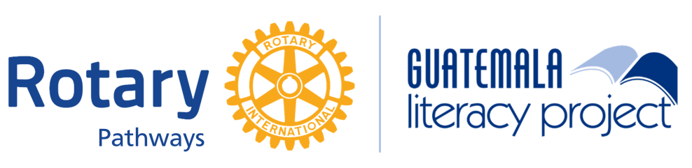
The Guatemala Literacy Project (GLP) is a network of Rotarians and CoEd
working together to improve literacy in Guatemala.

Display Board Kit

Set-Up Instructions

In this PDF you will find the following:
- Set-up instructions (page 1)
- Photo of display board set-up (page 2)
- Images to be used on the display board (pages 3–17)

Materials needed to make the display board:
- Tri-fold display board, at least 36 in x48 in (black suggested, available at Staples for ~US$15)
- Tape or glue stick
- Scissors or paper-cutter
- White paper (please use 11”x14” piece of paper for the GLP “title” logo if possible, as it is currently sized to fit those dimensions in this document)
- Printer

Instructions
- Obtain materials listed above.
- Print color copies of the images included in this PDF (pages 3–17).
- Cut out the images from the printed PDF document.
- Arrange the images on the display board, referring to the enclosed photo (page 2) of where to place the images.
- Using tape or a glue stick, secure the images onto the display board.
- Feel free to replace any of the photos with your own!

Additional table materials provided by the GLP (upon request, allow time for postage):
- GLP Project Brochures or GLP Info Sheet (printable)
- Project Tour Brochures

Any questions? Contact Emily Swisher at emily.swisher@coeduc.org or (513) 956-9002

Thank you for spreading the word about the Guatemala Literacy Project! Good luck!

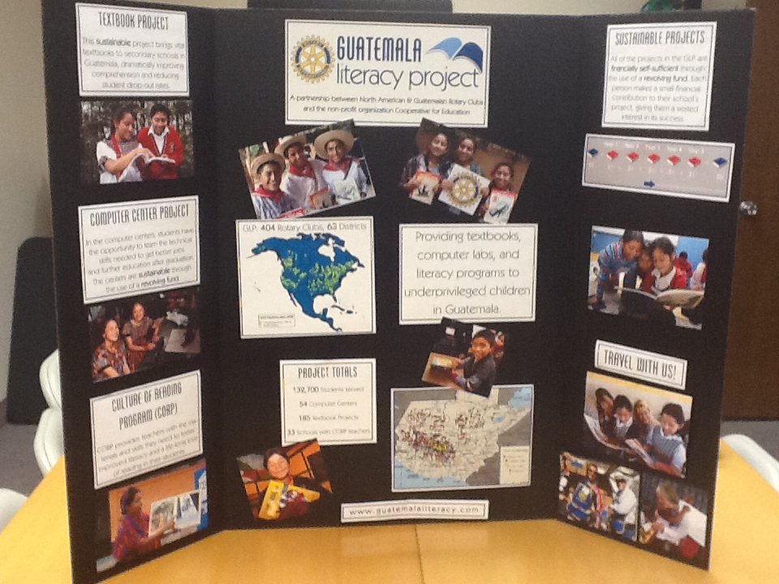

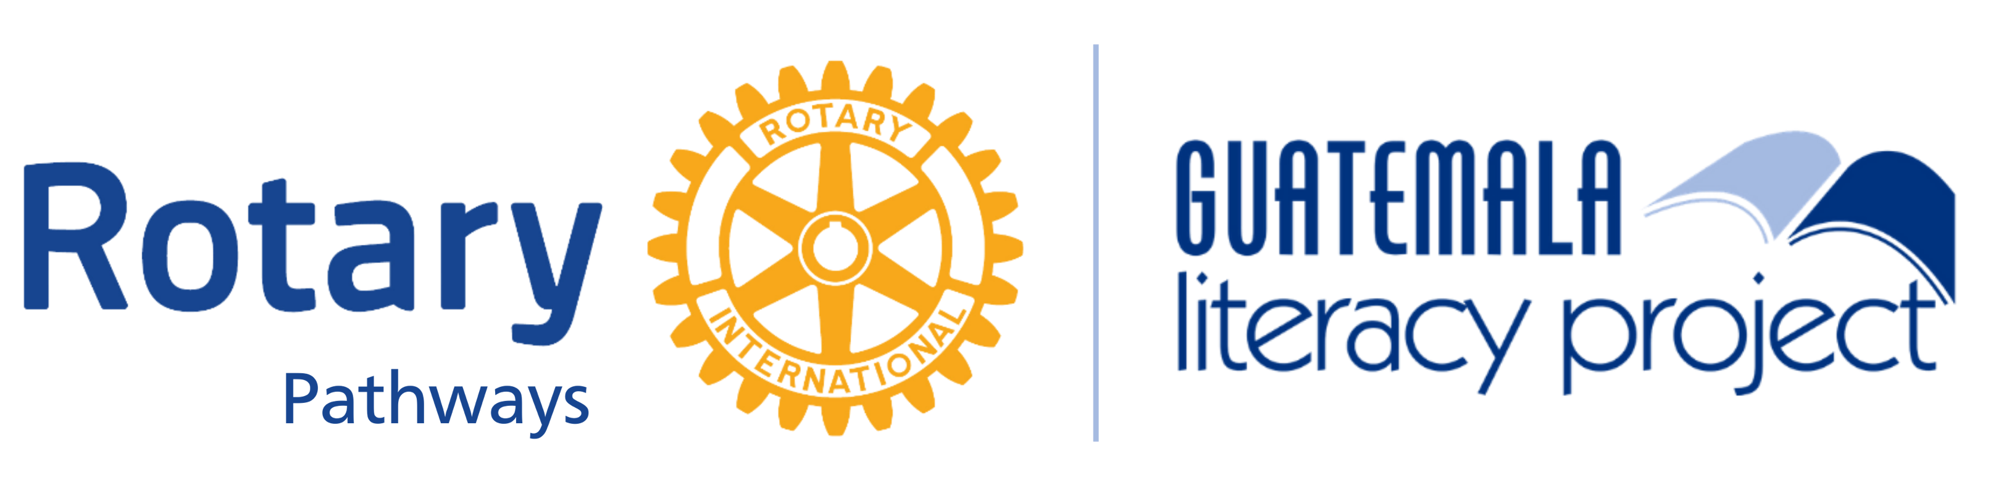

The Guatemala Literacy Project (GLP) is a network of Rotarians and CoEd
working together to improve literacy in Guatemala.

Textbook Project
This sustainable project brings vital textbooks to secondary schools in Guatemala, dramatically improving comprehension and reducing student drop-out rates.

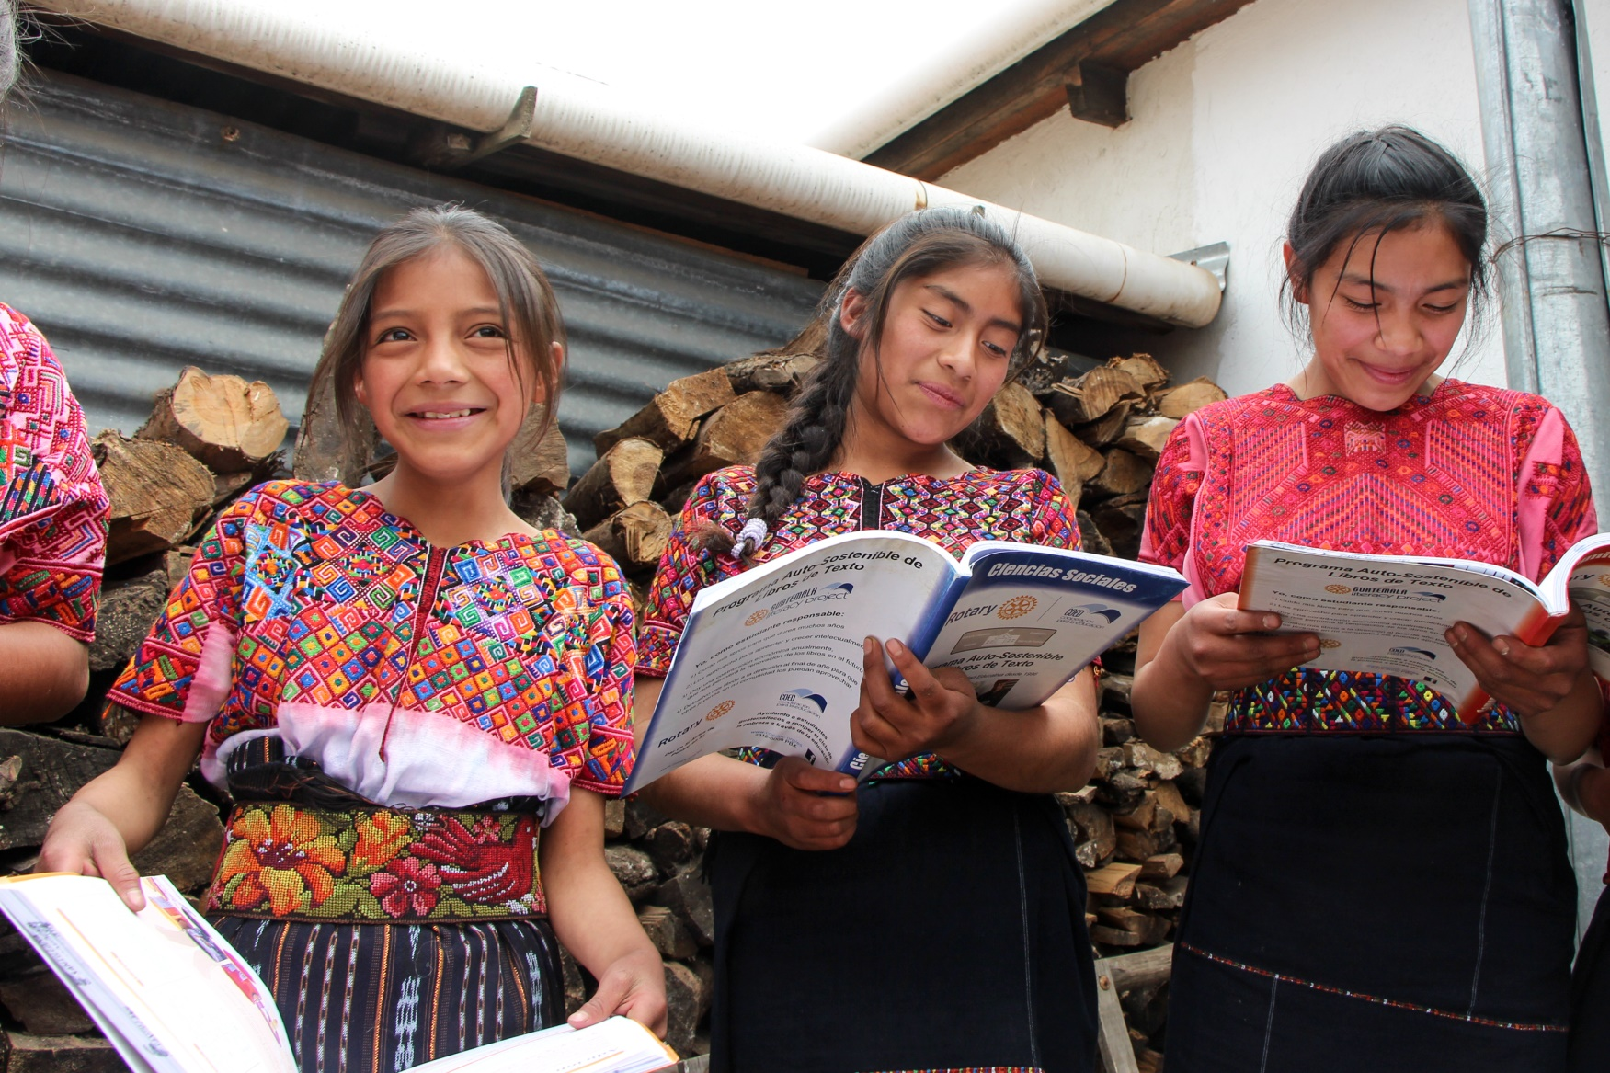
Computer PROGAM
In the Computer Program, students have the opportunity to learn the technical skills needed to get better jobs and further education after graduation. Computer centers are sustainable through the use of a revolving fund.

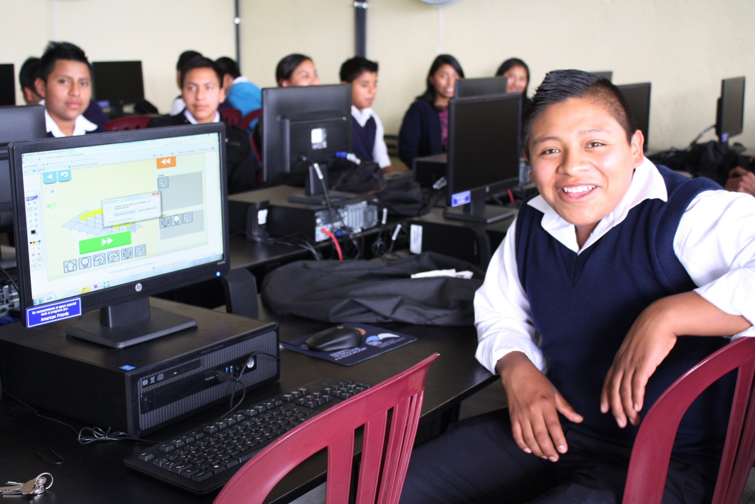
Spark reading program
Spark provides teachers with the materials and skills they need to foster improved literacy and a life-long love of reading in their students.
reducing student drop-out rates.

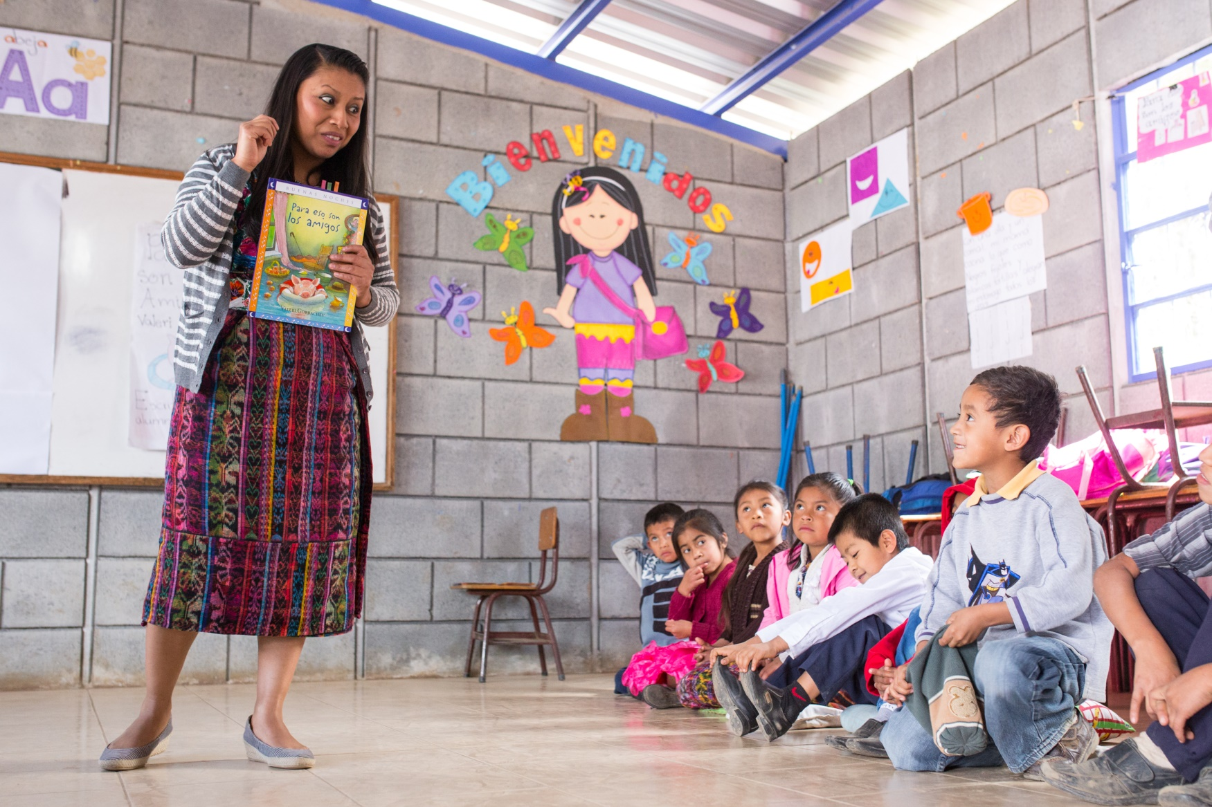
Rise program
This program gives promising youth who would otherwise drop out of school with the tools needed to stay in school and break out of poverty.

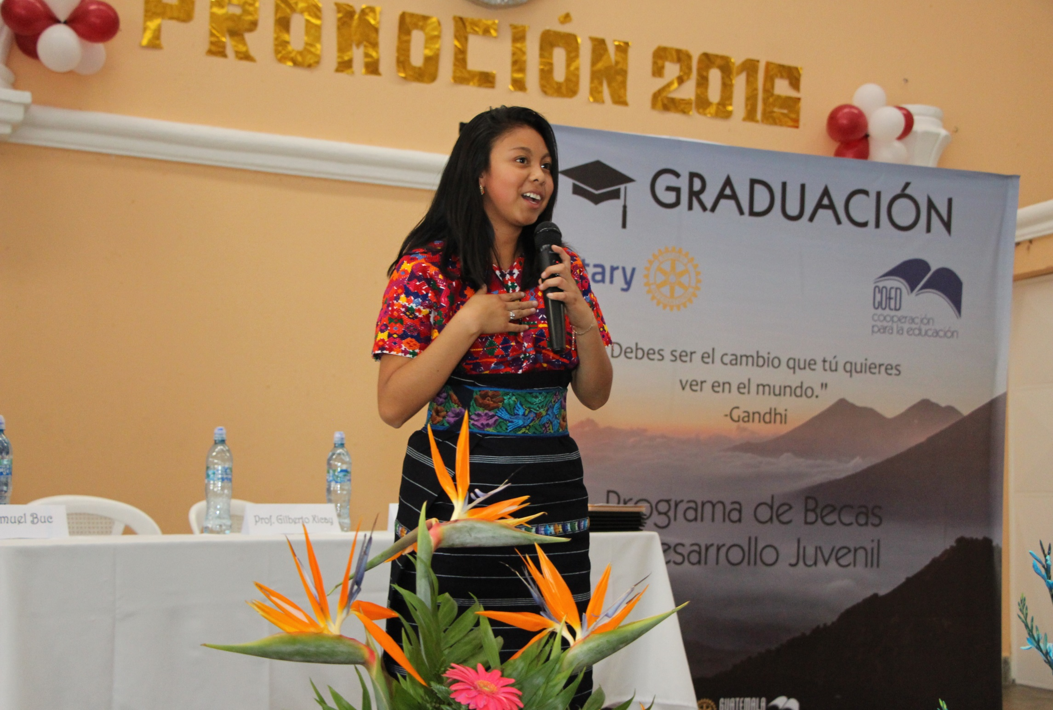
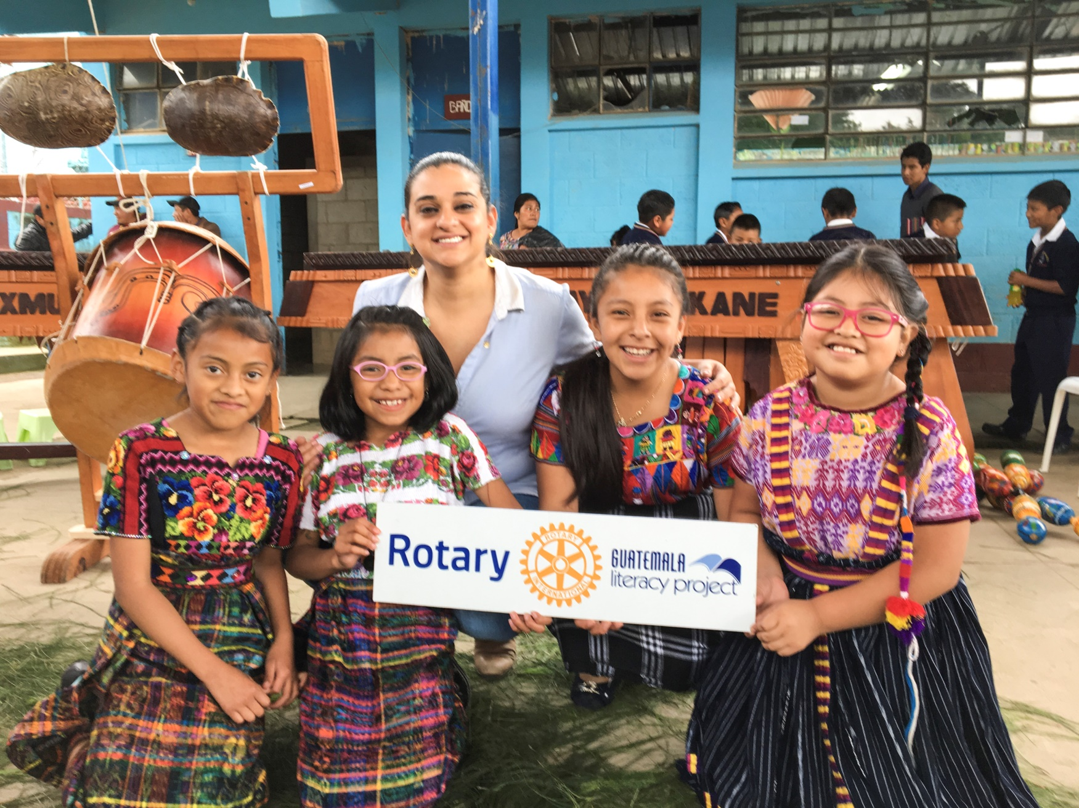
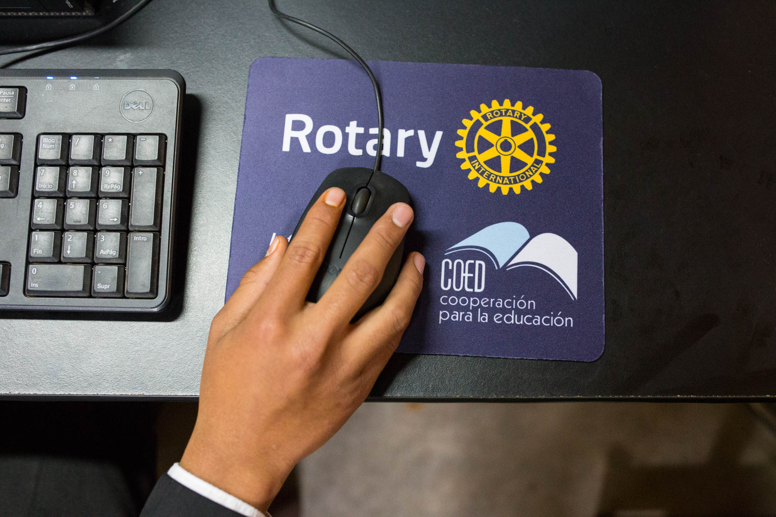

GLP: 817 Rotary Clubs, 99 Districts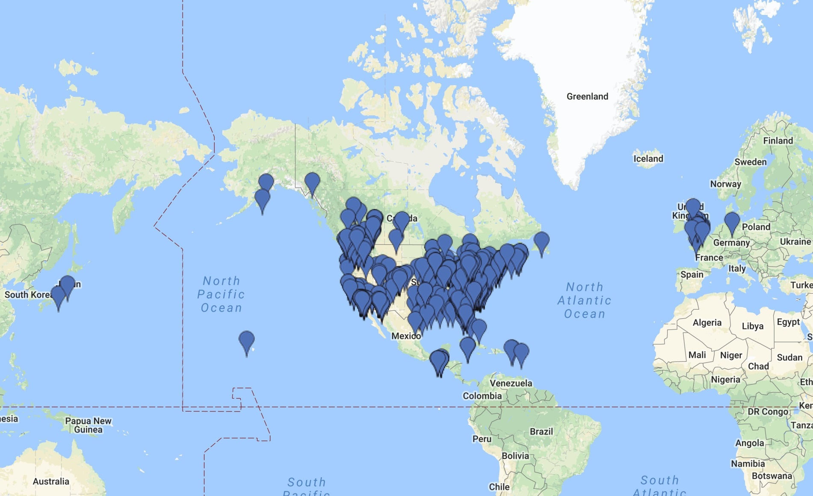

Since 1997, the GLP has partnered with 817 Rotary Clubs and
99 Districts in 11 countries and 2 territories: Guatemala, United States, Canada, United Kingdom, Cayman Islands, Bahamas, St. Kitts and Nevis, Germany, Italy, Poland, and Japan; Puerto Rico (US) and St. Croix. (US).
Providing textbooks, computer labs, reading programs, and youth development to underserved students
in Guatemala.
PROJECT TOTALS
295,079 Students Served
180 Textbook Schools
57 Computer Centers
152 Schools with Spark teachers
1,056 Scholarship Students

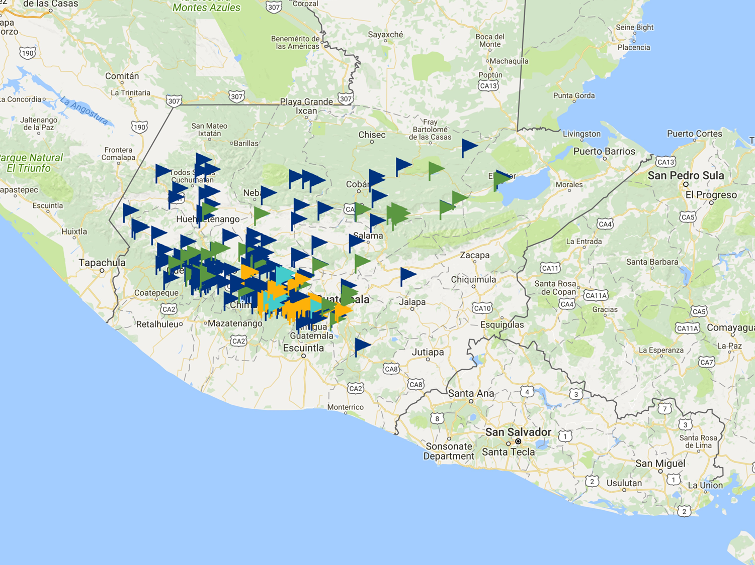
 Textbook Projects
 Computer Centers
 CORP Schools
 Youth Development Communities

www.guatemalaliteracy.org

Travel with us!

SUSTAINABLE PROJECTS
The Textbook and Computer Center projects in the GLP are financially self-sufficient through the use of a revolving fund. Each person makes a small financial contribution to their school’s project, giving them a vested interest in its success.

